## Sprint 1 Burndown Chart

**Sprint 2**

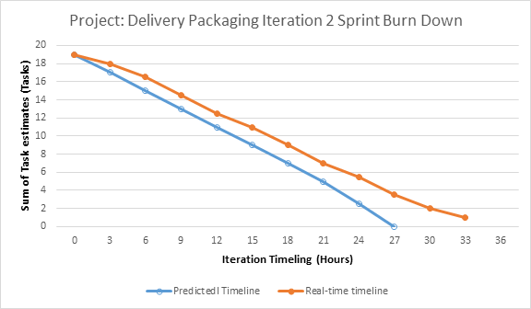

**Release 2**

**Sprint 3**

**Sprint 4**